**RESEARCH REPORT**

**TECHNOLOGY AND DESIGN THINKING: A LOOK AT INTERIOR DESIGN STUDENTS’ CONCEPTUALIZATIONS**

**ABSTRACT**

The motivation behind this qualitative study is to investigate interior design students’ comprehension of their structure thinking, and to explore how they see computerized innovation's job in these exercises. Members viewed interior design as more touchy to the human condition than design. AutoCAD was one programming bundle that was utilized both all the while and the finished result, however other more normal software programs (word processors, spreadsheets) were just negligibly used. Hypermedia and databases were not referenced by any members as devices in their structure forms [1].

**INTRODUCTION**

An interior designer must fuse an expansiveness of information looking for imaginative, sheltered, creative, suitable, stylishly satisfying structures that are as per codes and principles (Harmon-Vaughn, 2002). So as to teach interior design understudies for these later obligations, the structure studio gives an instructive scene to build up these abilities and information territories. The studio is the focal point of plan training around there, so it is pivotal to educate both workforce and understudies on practices and speculations that help to improve learning and guidance inside this given setting. The progression and change inside the advancement of configuration believing is investigated through audit of key writings and hypothetical ideas from early psychological models up to current models of parametric structure thinking. It is suggested that the original job for parametric outline, as a vital mode of parametric plan thinking, is defined at the crossing point of three assemblages of information: psychological models of typological and topological structure in engineering; process models of advanced plan; and structural request of material creation plan (MFD) [2].

**PURPOSE OF STUDY**

The purpose behind this subjective examination is to investigate interior plan understudies' comprehension of their structure thinking forms, and to research how they see advanced innovation's job in helping with this assignment. Does the idea of their PC innovation utilize more for envisioning their plan arrangements and for planning formal introductions instead of as an instrument to grow their intellectual abilities? In a past report, Brunner (2004) found that understudies presented to construction-based learning apparatuses had more composed, all the more hypothetically based plan choices, and preferable structure arrangements generally speaking over understudies who didn't utilize such learning devices. Be that as it may, in a subsequent report, Brunner and Fowles (2006) detailed that there were no observable or enduring impacts of this learning instrument [3]. Except if understudies practice such systems and understand that they in truth are significant in their learning, they won't keep on building these "propensities". Along these lines, a significant part of enduring impacts might be the understudies' origination of the significance of these learning procedures in their self-improvement as structure understudies.

**LITERATRE REVIEW**

Configuration is an omnipresent human movement. Configuration is esteemed by people, groups, associations, and societies. There are designs and repetitive wonders over the differing set of ways to deal with structure and furthermore fluctuations. Creators can profit by utilizing reasonable instruments like procedure models, techniques, and plan standards to enhance structure marvels. There are numerous variation procedure models, strategies, and standards for plan. Similarly, use of these calculated devices separates in mechanical settings. Creator present an incorporated procedure model, with model techniques and structure rules that is integrated from a survey of a few contextual analyses in customer based modern plan ventures for item, administration, and framework improvement, proficient instruction courses, and writing audit. Ideas from a few parts of configuration practice: (1) plan thinking, (2) business structure, (3) frameworks building, and (4) plan designing are incorporated. A plan procedure model, technique set, and set of preoccupied structure standards are proposed [4].

**DESIGN THINKING STUDIES**

As far as beginner originations of structure and the ramifications of these on the plan of learning situations, Newsteller and McCracken (2001) accept that structure understudies have very much evolved earlier originations and hypotheses about the idea of plan that contention with understandings held by master planners. Earlier information is a fundamental variable in configuration learning. Chi, Glaser, and Farr (1998) alert earlier information, be that as it may, is regularly erroneous. Lawson (2006) contends that thinking and envisioning are likely the most significant sorts of intuition for creators [5].

**TECHNOLOGY AND EDUCATION**

Jonassen, Peck, and Wilson (1999) accept that PCs ought to be viewed as psychological accomplices for enhancing and revamping data, just as aiding practice—yet the correct sort of training. Moreover, advancements ought to be thought of as instruments to assist students with rising above the restrictions of their brains, for example, memory, thinking, or critical thinking constraints. At the point when students use advances as accomplices, they off-load a portion of the useless remembering errands, permitting them to think all the more gainfully. The objective in utilizing innovations ought to be to dispense to the students the psychological duty regarding the handling they do best while assigning the preparing that innovation does best. However, Taylor (1980) saw the tutee method of the PC as the most encouraging furthermore, best for instruction experts and researchers [6]. Here, the understudy mentors and should figure out how to program or to converse with the PC in a language it gets it.

**METHODOLOGY**

This investigation was an essential interpretive subjective examination configuration to all the more likely see how members make importance of their structure thinking and their origination of PC innovation in this procedure. A subjective exploration configuration was chosen on the grounds that the point of this examination was to investigate certain implications, qualities, and jobs of a specific marvel top to bottom [7]. It was additionally essential to additionally research this zone, in light of past outcomes from a quantitative report tending to these comparable points (Brunner, 2007).

**PARTICIPANTS**

Semi-structured meetings were gotten from six college understudies (two sophomores, two youngsters, and two seniors) in the inside structure program. The six members were chosen from the gathering of understudies as of now tried out the undergrad inside structure program [8].

**RESULTS**

From the examination inquiries there were three fundamental subjects that rose up out of the investigation of the information. Subsequently, the conversation of the outcomes is introduced under these three territories [9]. It ought to be noticed that on the grounds that the "procedure book" is as of now a huge piece of the plan procedure and its clashing jobs in helping understudies in their structure thinking, a different region is justified for the procedure book.

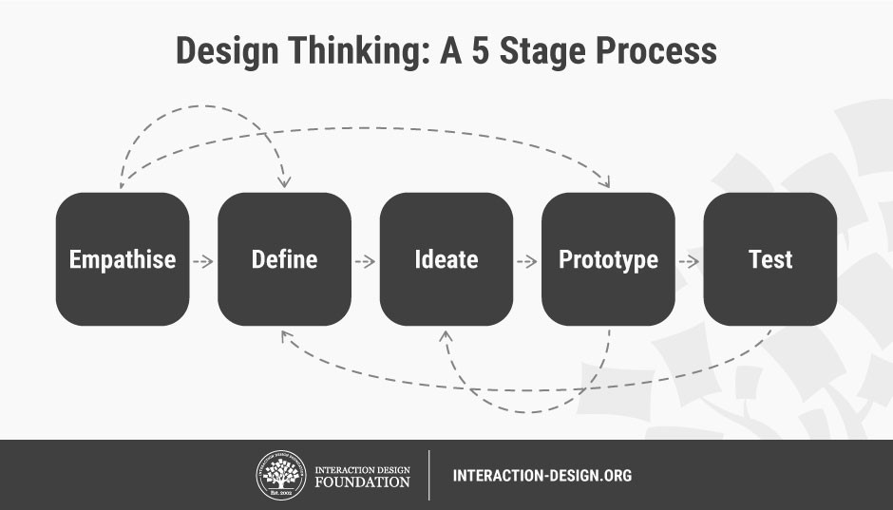

**Figure 1. 5 Stages in the Design Thinking**

**Table 1. Participants Opinion**

|  |  |
| --- | --- |
| **Number of Students** | **Students’ Conceptualization** |
| Participant 1 | It is involved with addressing the Human Condition. |
| Participant 2 | It is a King of Biggest Thing. |
| Participant 3 | It is more important for Interior Designer and it is Motivating. |
| Participant 4 | Start loving what you do , you have to be obsessed with it. |
| Participant 5 | He says about the importance of science and arts. |
| Participant 6 | He mentioned about importance of sketching. |

**DISCUSSIONS**

The information from the meetings were both area explicit and space general as far as conceptualizations of plan and an individual's overall achievement in a calling. As for inside structure, understudies were very unequivocal on the differentiations among engineering and inside plan. Specifically, the members saw inside structure as more delicate to the human condition and the significance of needing to help individuals or customers [10]. Other significant qualities that a decent fashioner must have as indicated by these members were being sorted out, inspired, innovative, and open to all thoughts or impartial.

**FUTURE DIRECTIONS**

This Study starts the investigations of the importance, utility, and job of the procedure book in the inside plan studio. While the goal of this curio may in actuality be to give a wellspring of documentation of the entirety of the understudy's work in a specific structure venture, this substance has a lot more to offer the understudies, educators, and conceivably even future managers. What isn't yet evolved is the worth and job the procedure book has for structure teachers. Accordingly, a future report will investigate these zones from this point of view.

**REFERENCES**

[1] - Brunner, L. A. (2007). Technology and design thinking: A look at interior design students’ conceptualizations.

[2] - Brunner, L.A., Fowles, D.L. (2006). Are there lasting effects of a schema-based learning system? Paper presented at the International Conference of the Interior Design Educators Council (IDEC), Scottsdale, AZ.

[3] - Brunner, L.A. (2007). Student Perspectives on Design, Learning, and Interior Design Education. Paper presented at the 2007 International Conference of the Interior Design Educators Council (IDEC), Austin, TX.

[4] - Chi, M.T., Glaser, R., Farr, M. (1998). The nature of expertise. Hillsdale, NJ: Lawrence Erlbaum and Associates. Cross, N. (2011). *Design thinking: Understanding how designers think and work*. Berg.

[5] - Coffee, A., Atkinson, P. (1996). Making Sense of Qualitative Data. Thousand Oaks, CA: Sage. Dewey, J. (1933). How We Think: A restatement of the relation of reflective thinking to the reflective process (Revised Edition), Lexington, MA: Heath.

[6] - Jonassen, D.H., Carr, C., Yueh, H-P. (1998). Computers as mindtools for engaging learners in critical thinking. TechTrends, v 43 n 2 pp. 24-32 Mar.

[7] - Mayer, R.E. (1979). Can advanced organizers influence meaningful learning? Review of Educational Research, 49, 371-383.

[8] - Miles, M.B., Huberman, A.M. (1994). Qualitative data analysis: An expanded sourcebook. Thousand Oaks, CA: Sage Publications.

[9] - Newsteller W.C., & McCracken, W.M. (2001). Novice conceptions of design: Implications for the design of learning environments. In C.M. Eastman, W.M. McCracken, W.C. Newstetter (Eds.), Design knowing and learning: Cognition in Design Education (pp. 63-77). Amsterdam: Elsevier.

[10]- Taylor, R.P. (1980). Introduction. In R.P. Taylor (Ed.), The computer in school: Tutor, tool, tutee (pp. 1- 10). New York: Teachers College Press.